AIM:

Currently, visually impaired are also using smartphones, the existing applications are user-friendly but not for visually impaired. To simplify the usage of application we propose an innovative and essentials need for them such as indoor navigation using inbuilt speakers and mic (VIA ULTRASONIC SOUND WAVE), similarly we also propose various activities such as object identification, bus stop locator/navigator and transaction of money in ATM using swipe gestures. The main objective of this project is to make visually impaired people to perform their routine task in day to day life without the help of others.

TECHNICAL DETAILS, SCOPE, DESIGN, RESOURCE ETC:

**OBSTACLE DETECTION (INDOOR):**

The user can enter this activity by Swiping UP. In this activity, obstacles can be detected by passing a constant ultrasonic waves (i.e., 15Hz). Normally the frequency of a reflected wave of an Obstacle is greater than the original frequency .Based on this concept, obstacles are detected. The ultrasonic wave is transmitted through the inbuilt speakers and it is monitored through the microphone. If some Obstacle is detected, the transmitted ultrasonic wave is repelled back and produces a greater frequency which is above 15Hz.

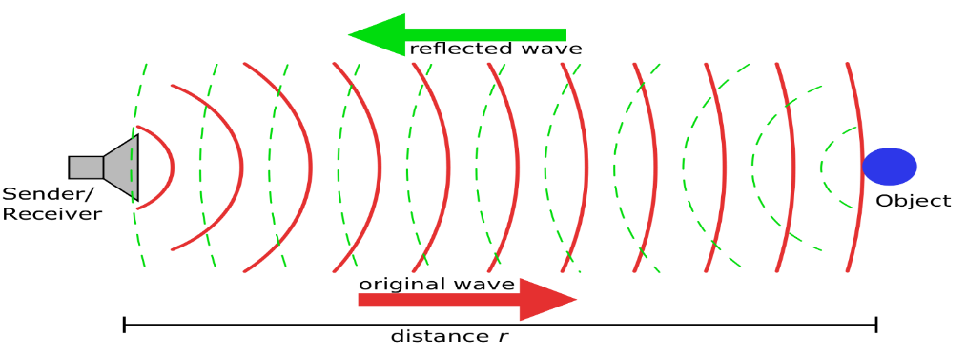

This triggers the haptic feedback such that the impaired person gets aware of the Obstacle. On other hand, if there is no Obstacle, the Produced frequency will be lesser than that of Actual frequency and thus triggering pulse stops. (This concept is based on BAT logic).

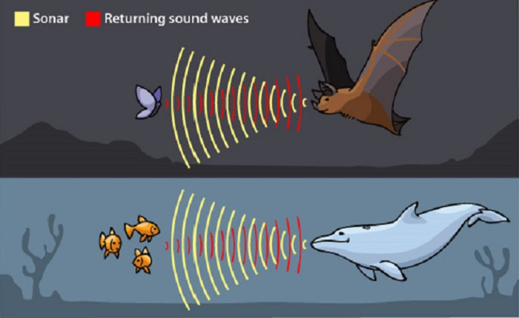

 **BUS NAVIGATION:**

The user can enter this activity by Swiping RIGHT .The main idea of this activity is to help the visually impaired people to identify the bus stops and also to provide the visually impaired person’s current location to their care takers. In this, the latitude and longitudinal co-ordinates are obtained in the map. And this provides the information about the current location of the bus stops and distance between the adjacent stops.

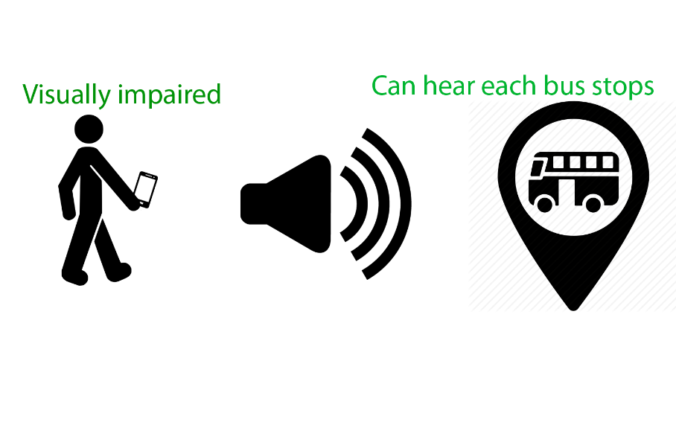

It utilizes both GPS and network access to obtain the precise location.

** OBJECT IDENTIFIER:**

The user can enter this activity by Swiping DOWN.This activity enables the visually impaired person to recognize and identify various objects. When the person wants to know “what the Object is”, he/she takes a picture of that object (via phone camera) and that particular object is uploaded into the Google images automatically.

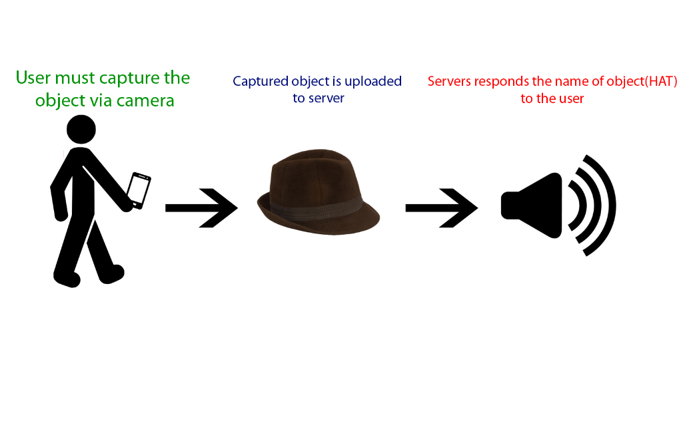

This fetches the relevant information of that object and gives an appropriate answer in the search tab. This answer is provided as an output (through voice) to the visually impaired person. Using this, the person can recognize any type of objects such as apple, toothpaste, Money, dollar, hardware devices etc.

**ATM:**

The user can enter this activity by Swiping LEFT .The main objective of this activity is to provide ease of accessing ATM by visually impaired people. Initially, the impaired person inserts the ATM card into the ATM machine, the machine generates a QR code of a secured tunnel (based on the card details).When the person scans this QR code, he/she is redirected to the secured link (via 128 bit encryption).Now the link requests the user to enter the pin to start any type of transaction related activities. The person enters the pin with the help of vibrate feedback (for example, when the user wants to enter “2” the device vibrates twice) .This vibrate feedback is for the security purpose of the pin. Once the correct pin is entered, the person can perform any kind of bank related activities such as withdrawal, fast cash, pin change, enquiry, balance etc.,

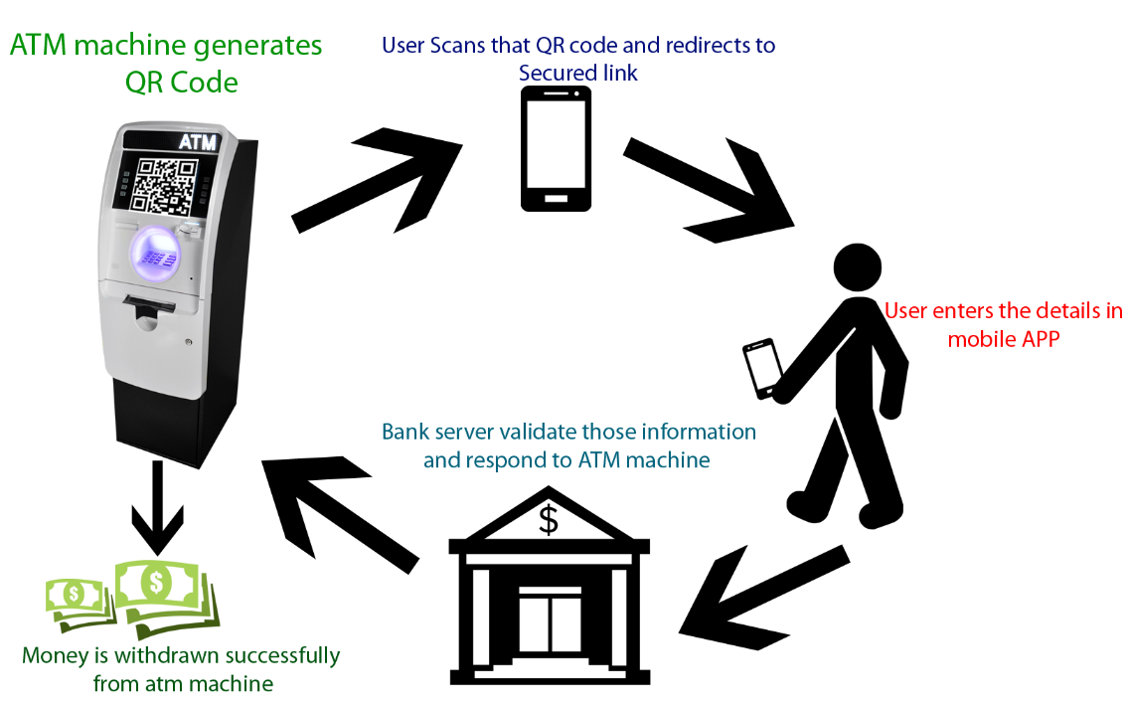

**MARKET POTENTIAL AND COMPETITIVE ADVANTAGE:**

This android application does not require any special add-ons like arduino board, sensor’s or other hardware resources (i.e., consumes very less resources and requires no specialized sensors).More over this application is compatible with any android version starting from android 4.0(ICE-CREAM SANDWICH).Our android app consists of four different activities combined in one application. This app can also be used as a launcher application.

**INNOVATIVENESS AND USEFULNESS (WHY YOUR PROJECT SHOULD BE SELECTED AS AN INNOVATIVE PROJECT):**

The main aim of this project is to make the visually impaired Person to perform various activities that a normal person can do with an ease using their Smart Phone. And even the Visually Impaired people have their own goals and this APP helps them to take a step forward to achieve their success.  And our ultimate GOAL is to make VISION LESS WORLD (IN SMARTER WAY). The ability of ATM Transaction for blind removes their inferiority complex (that they can’t do anything without eyes) and improves their self-confidence (that they can do each and every essential things even without eyes).

**PROJECT ACHIEVEMENTS:**

Our project has won 1st prize in “Hackerz ver2.16, at Chennai Institute of Technology symposium “in Mobile App innovation competition.

**SCREEN SHOTS:**

**OBSTACLE DETECTION - INDOOR:**

*Constant Sound *Vibrate, once it crosses constant sound

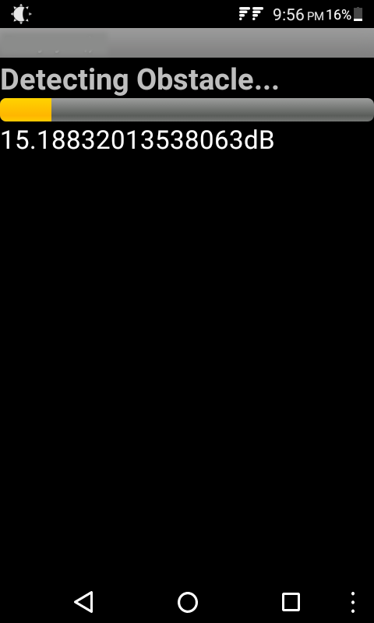 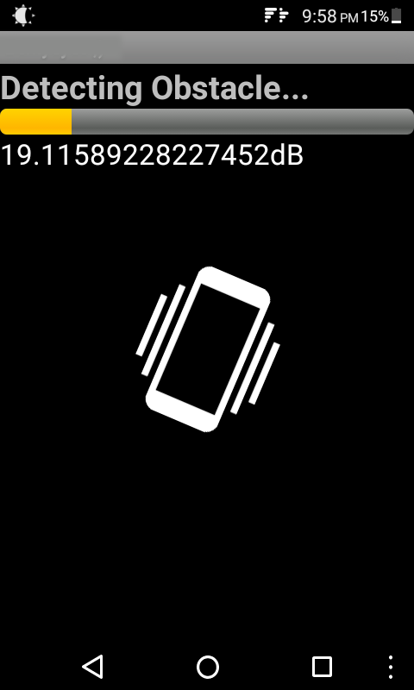

** OBJECT IDENTIFIER: (IN PROGRESS)**

*Capturing image via camera *Uploading to Google images, and waiting for response

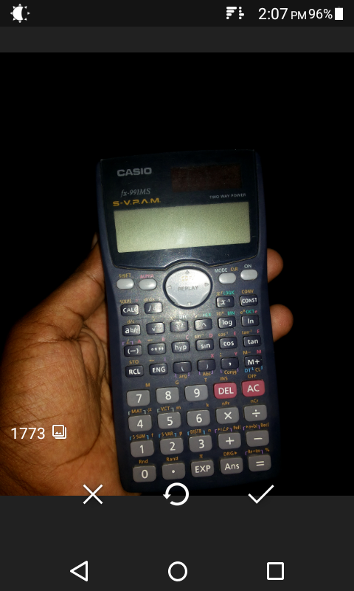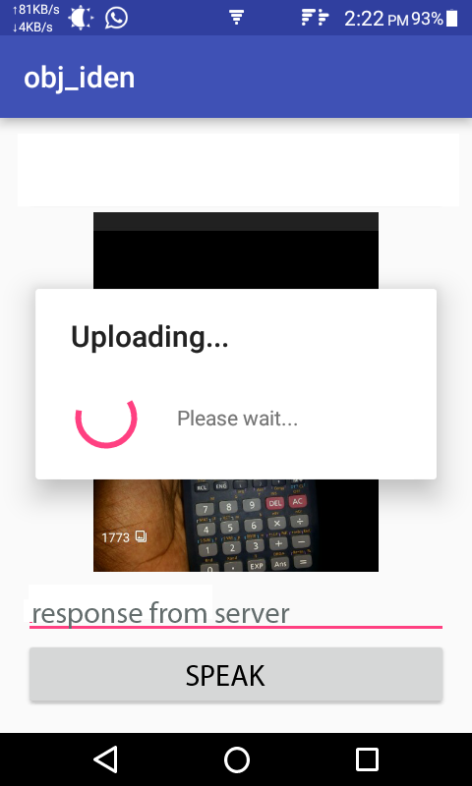

*After getting response, user can hear the name of the object.

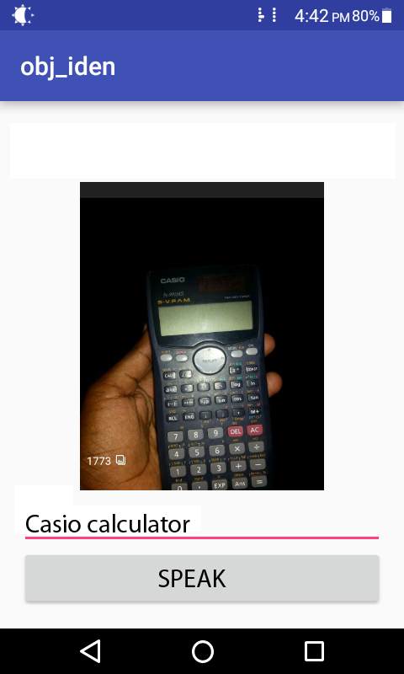

**ATM:**

*User must scan the QR Code from an ATM machine.

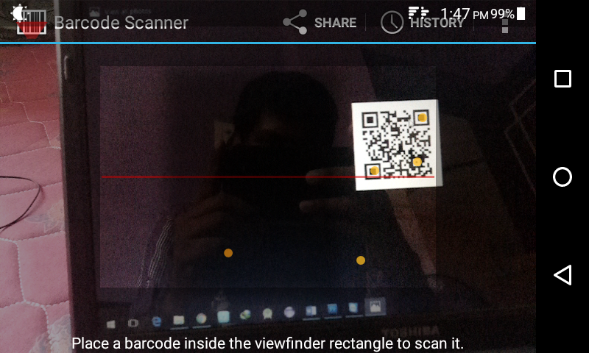

*User can enter the PIN number using haptic feedback.

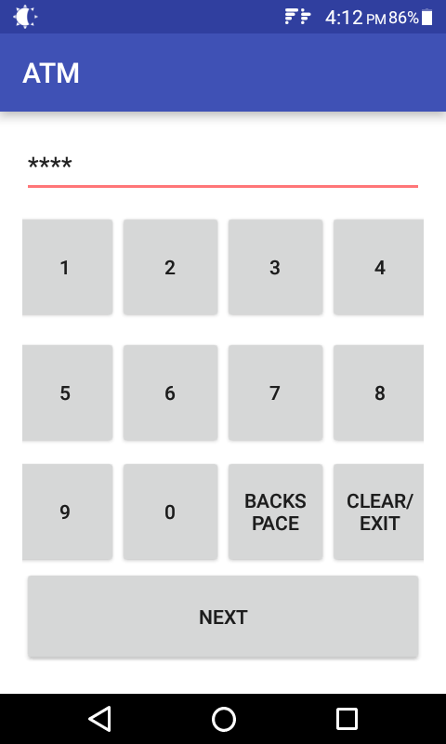 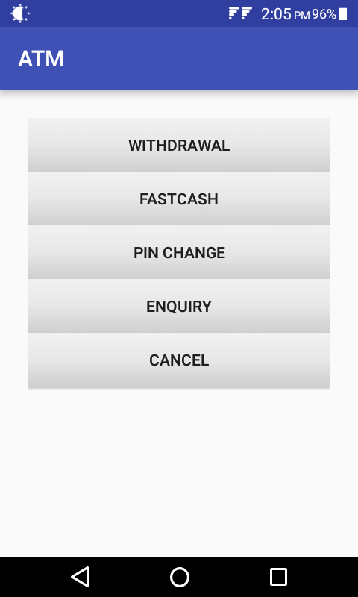

*By using this app the visually impaired can perform various task start from amount withdrawal to enquiry status. (WITHOUT ANYONE’S HELP).

*User can enter their desired amount (via TTS guidance) and complete the transaction.

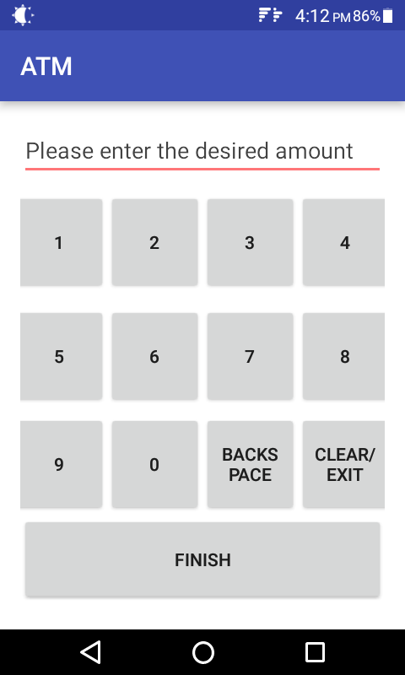 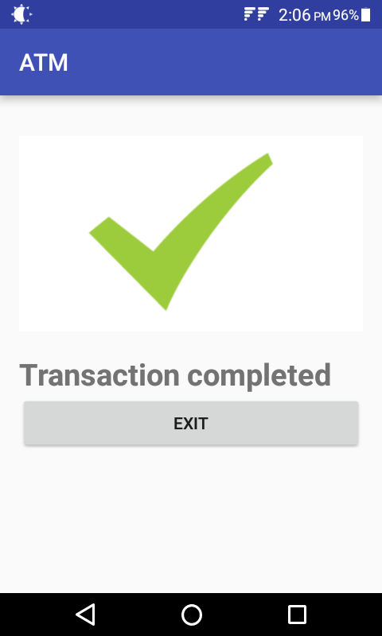

** BUS NAVIGATION: (IN PROGRESS)**

*Various Bus stops were marked in OMR.

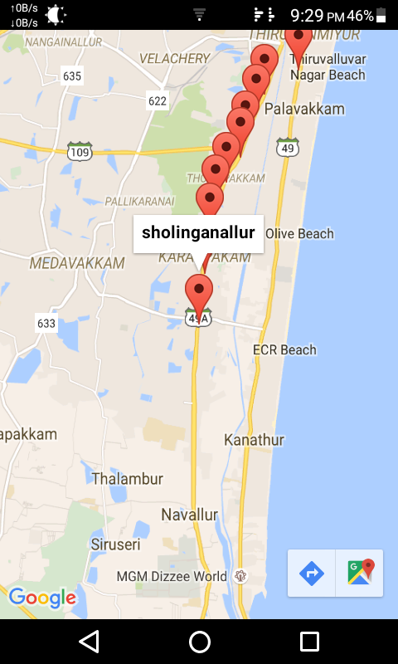 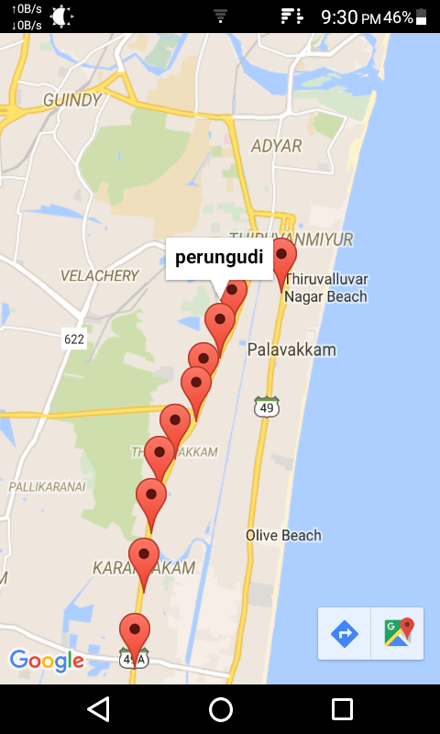 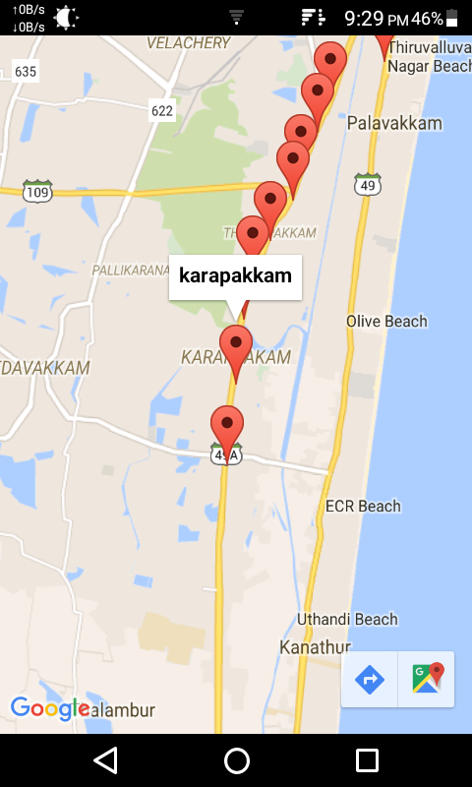

**RESEARCH:**

We went to St. Louis blind school Adyar, to check our compatibility and real time usage of our application and we got many positive feedbacks.

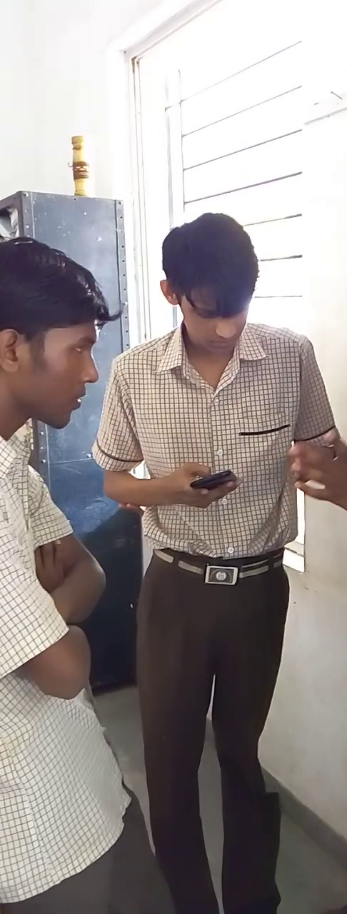 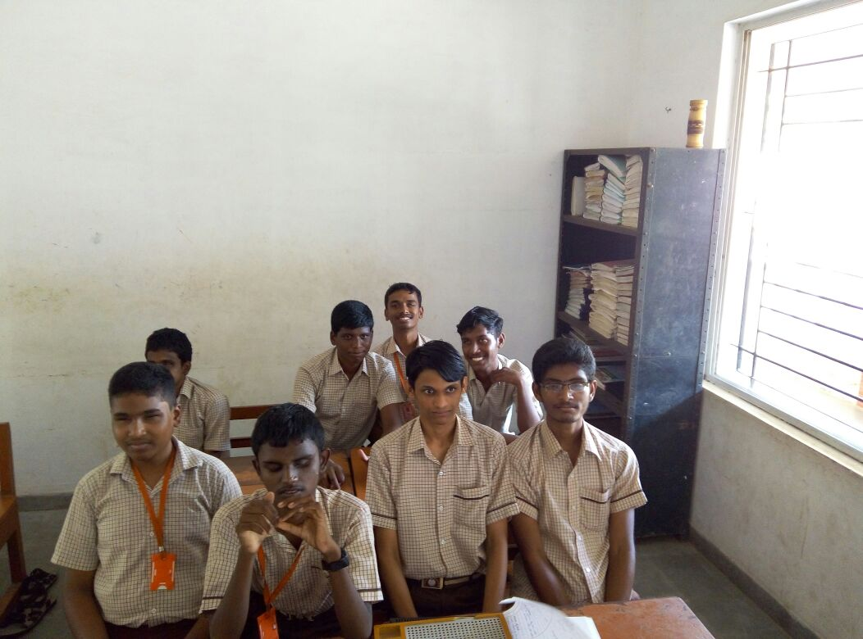

**CONCLUSION:**

In this document, we have proposed new intelligent system for guiding and handlings their essential tasks of individuals who are visually impaired. If this app is developed and implemented, it will act as a basic platform for the future generation of visually impaired. The experimental results have shown the usefulness of the application in allowing blind people to move independently, safely and quickly among obstacle.